Resemblance of Legionella Untreated Controls
COST: Biofilm Regulatory Toolbox
8 Sept 2026
Showing Resemblance of Legionella untreated control biofilms generated by an ISBR reactor at CBE. These data were published by Bodle et al 2026:
Bodle et al. Assessing a method for single- and multidomain biofilm growth in a novel biofilm reactor: shear stress, ruggedness, repeatability, and reproducibility. Biofilm 100372, 2026

Housekeeping
library(lme4) # lmer()
## Warning: package 'lme4' was built under R version 4.4.2
## Loading required package: Matrix
source("diagRES.r")
library(lmerTest)
## Warning: package 'lmerTest' was built under R version 4.4.2
##
## Attaching package: 'lmerTest'
## The following object is masked from 'package:lme4':
##
## lmer
## The following object is masked from 'package:stats':
##
## step

Get the Data
d = read.csv("Parker_10-11_LegionellaControlData.csv",stringsAsFactors = TRUE)
summary(d)
## Exp CFU.cm2
## Min. :1 Min. :15490
## 1st Qu.:1 1st Qu.:27365
## Median :2 Median :39757
## Mean :2 Mean :35053
## 3rd Qu.:3 3rd Qu.:41823
## Max. :3 Max. :42855

Plot the Data
plot(d$Exp,log10(d$CFU.cm2),xlab="Experiment",ylab="log(CFU/cm2)")
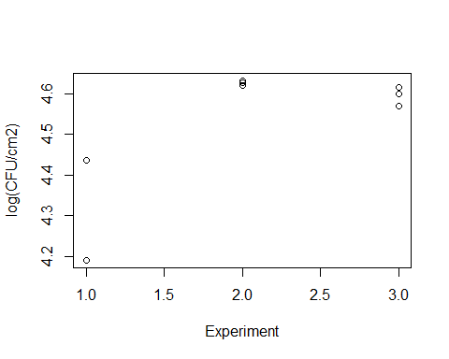

Mixed effects model

Fit LMM to data
m = lmer(log10(CFU.cm2) ~ (1|Exp),data=d)
summary(m)
## Linear mixed model fit by REML. t-tests use Satterthwaite's method [
## lmerModLmerTest]
## Formula: log10(CFU.cm2) ~ (1 | Exp)
## Data: d
##
## REML criterion at convergence: -10.3
##
## Scaled residuals:
## Min 1Q Median 3Q Max
## -2.18776 0.06373 0.13777 0.33652 0.77149
##
## Random effects:
## Groups Name Variance Std.Dev.
## Exp (Intercept) 0.019795 0.14069
## Residual 0.006975 0.08352
## Number of obs: 9, groups: Exp, 3
##
## Fixed effects:
## Estimate Std. Error df t value Pr(>|t|)
## (Intercept) 4.52559 0.08587 2.00000 52.7 0.00036 ***
## ---
## Signif. codes: 0 '***' 0.001 '**' 0.01 '*' 0.05 '.' 0.1 ' ' 1
confint(m)
## Computing profile confidence intervals ...
## 2.5 % 97.5 %
## .sig01 0.00000000 0.3553799
## .sigma 0.05186596 0.1674635
## (Intercept) 4.32984853 4.7213293

Check model assumptions
Constant variance and normality of coupon LDs in each experiment
diagRES(m,res="p",num.panes=4,tests=TRUE)
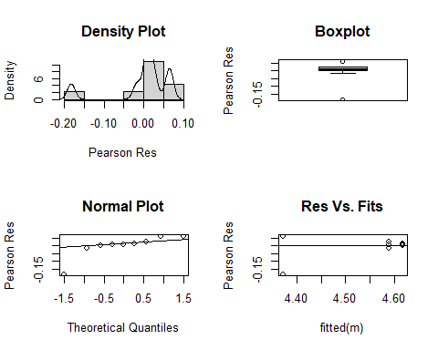
## [1] "In this sample of size n=9, correlation of the residuals in the qq-plot is r=0.835442"
## [1] "In the following table, if r < critical.r, then the qq-plot suggests the residuals are not normal:"
## n critical.r
## 1 5 0.832
## 2 10 0.880
## 3 15 0.911
## 4 20 0.929
## 5 25 0.941
## 6 30 0.949
## 7 40 0.960
## 8 50 0.966
## 9 60 0.971
## 10 75 0.976
##
## Shapiro-Wilk normality test
##
## data: r
## W = 0.72424, p-value = 0.002721
## Warning in ks.test.default(r, "pnorm"): ties should not be present for the
## one-sample Kolmogorov-Smirnov test
##
## Asymptotic one-sample Kolmogorov-Smirnov test
##
## data: r
## D = 0.47431, p-value = 0.03486
## alternative hypothesis: two-sided
# Check normality of experiment mean LDs
re=ranef(m)$Exp
qqnorm(re[,1])
qqline(re[,1])
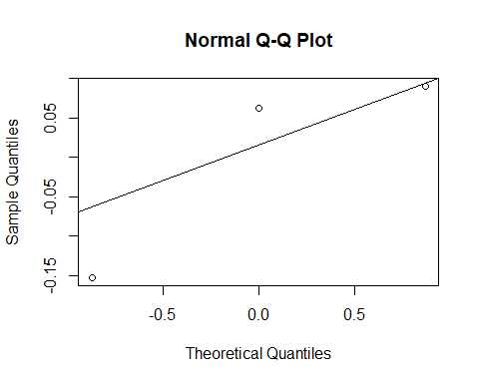

Summarize variance components
VarCorr(m)
## Groups Name Std.Dev.
## Exp (Intercept) 0.140694
## Residual 0.083519
vc = as.data.frame(VarCorr(m))$vcov
# Proportion of variance components
vc/sum(vc)
## [1] 0.7394331 0.2605669

Repeatability SD
Repeatablity SD = 0.5 log is considered acceptable for CFU assays.
Sr = sqrt(sum(vc))
Sr
## [1] 0.1636166

Calculations by hand
Mimicking what is done in Excel

Get a CI for the mean
This CI will be different than what profile CI from lmer( )
# Calculate the mean for each experiment
mean.Exp = tapply(log10(d$CFU.cm2),d$Exp,mean)
mean.Exp
## 1 2 3
## 4.354817 4.626719 4.595231
# Get confidence interval with a t-test
t.test(mean.Exp)
##
## One Sample t-test
##
## data: mean.Exp
## t = 52.704, df = 2, p-value = 0.0003598
## alternative hypothesis: true mean is not equal to 0
## 95 percent confidence interval:
## 4.156128 4.895050
## sample estimates:
## mean of x
## 4.525589

Get the repeatability SD and variance components
# Calculate the variance for each experiment
Var.Exp=tapply(log10(d$CFU.cm2),d$Exp,var)
# Variance Component
Vcoupon = mean(Var.Exp)
Vcoupon
## [1] 0.006975479
vc[2] # Check against lmer()
## [1] 0.006975479
Vexp = var(mean.Exp) - Vcoupon/length(mean.Exp)
Vexp
## [1] 0.01979491
vc[1] # Check against lmer()
## [1] 0.01979491
# Repeatability SD
sqrt(Vexp + Vcoupon)
## [1] 0.1636166
Sr # Check against lmer()
## [1] 0.1636166

Assess Outlier Influence
Refit the LMM to the data without the outlier and compare results.
m = lmer(log10(CFU.cm2) ~ (1|Exp),data=d[-3,])
summary(m)
## Linear mixed model fit by REML. t-tests use Satterthwaite's method [
## lmerModLmerTest]
## Formula: log10(CFU.cm2) ~ (1 | Exp)
## Data: d[-3, ]
##
## REML criterion at convergence: -27.3
##
## Scaled residuals:
## Min 1Q Median 3Q Max
## -1.64076 -0.14269 -0.02362 0.32112 1.40326
##
## Random effects:
## Groups Name Variance Std.Dev.
## Exp (Intercept) 0.010202 0.10100
## Residual 0.000226 0.01503
## Number of obs: 8, groups: Exp, 3
##
## Fixed effects:
## Estimate Std. Error df t value Pr(>|t|)
## (Intercept) 4.55319 0.05856 1.99533 77.75 0.000168 ***
## ---
## Signif. codes: 0 '***' 0.001 '**' 0.01 '*' 0.05 '.' 0.1 ' ' 1
confint(m)
## Computing profile confidence intervals ...
## 2.5 % 97.5 %
## .sig01 0.042783763 0.24446092
## .sigma 0.008988242 0.03282892
## (Intercept) 4.419601807 4.68661703
# Check model fit - constant variance and normality of coupon LDs in each experiment
diagRES(m,res="p",num.panes=4,tests=TRUE)
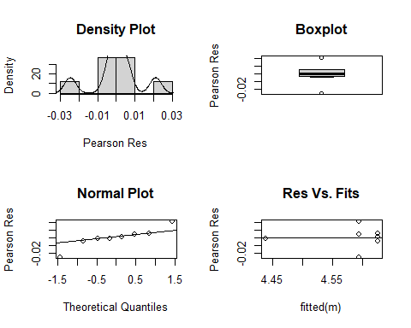
## [1] "In this sample of size n=8, correlation of the residuals in the qq-plot is r=0.936897"
## [1] "In the following table, if r < critical.r, then the qq-plot suggests the residuals are not normal:"
## n critical.r
## 1 5 0.832
## 2 10 0.880
## 3 15 0.911
## 4 20 0.929
## 5 25 0.941
## 6 30 0.949
## 7 40 0.960
## 8 50 0.966
## 9 60 0.971
## 10 75 0.976
##
## Shapiro-Wilk normality test
##
## data: r
## W = 0.91174, p-value = 0.3665
## Warning in ks.test.default(r, "pnorm"): ties should not be present for the
## one-sample Kolmogorov-Smirnov test
##
## Asymptotic one-sample Kolmogorov-Smirnov test
##
## data: r
## D = 0.49159, p-value = 0.04186
## alternative hypothesis: two-sided
# Check normality of experiment mean LDs
re=ranef(m)$Exp
qqnorm(re[,1])
qqline(re[,1])
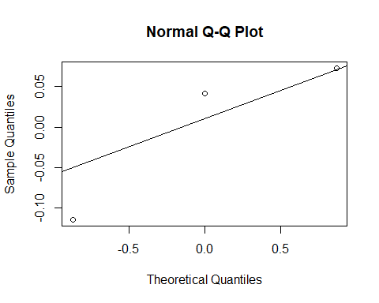
# Repeatability SD
sqrt(sum(as.data.frame(VarCorr(m))$vcov))
## [1] 0.1021159

