LRs
COST: Biofilm Regulatory Toolbox
8 Sept 2026
Showing Repeatability of synethtic efficacy data against Legionella generated by an ISBR reactor at CBE.

Input Data
LR = c(3.214,3.577,2.886)

Plot the data
plot(1:3,LR,xlab="Experiment")
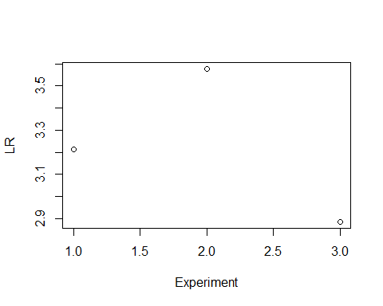

Get mean and repeatability SD
mean(LR)
## [1] 3.225667
sd(LR) # repeatability SD
## [1] 0.3456477

Assess true mean LR with t-tests
# Two sided 95% CI
t.test(LR)
##
## One Sample t-test
##
## data: LR
## t = 16.164, df = 2, p-value = 0.003806
## alternative hypothesis: true mean is not equal to 0
## 95 percent confidence interval:
## 2.367030 4.084303
## sample estimates:
## mean of x
## 3.225667
# One-sided 95% CIs
t.test(LR,alternative = "greater", mu=2)
##
## One Sample t-test
##
## data: LR
## t = 6.1419, df = 2, p-value = 0.01275
## alternative hypothesis: true mean is greater than 2
## 95 percent confidence interval:
## 2.642955 Inf
## sample estimates:
## mean of x
## 3.225667
t.test(LR,alternative = "greater", mu=3)
##
## One Sample t-test
##
## data: LR
## t = 1.1308, df = 2, p-value = 0.1877
## alternative hypothesis: true mean is greater than 3
## 95 percent confidence interval:
## 2.642955 Inf
## sample estimates:
## mean of x
## 3.225667

Check t-test assumptions
For small samples, normality is required. Check for outliers.
par(mfrow=c(1,2))
hist(LR)
qqnorm(LR)
qqline(LR)
