Responsiveness of MBEC
COST: Biofilm Regulatory Toolbox
8 Sept 2026
Showing Responsiveness of the MBEC to different concentrations of an oxidizer against Pseudomonas biofilms. Data generated by a single lab from an 8-laboratory study and reported by Parker et al 2019:
Parker, mbec …

Housekeeping
library(lme4) # lmer()
## Warning: package 'lme4' was built under R version 4.4.2
## Loading required package: Matrix
source("diagRES.r")
library(lmerTest)
## Warning: package 'lmerTest' was built under R version 4.4.2
##
## Attaching package: 'lmerTest'
## The following object is masked from 'package:lme4':
##
## lmer
## The following object is masked from 'package:stats':
##
## step
library(effects)
## Warning: package 'effects' was built under R version 4.4.3
## Loading required package: carData
## Warning: package 'carData' was built under R version 4.4.3
## lattice theme set by effectsTheme()
## See ?effectsTheme for details.
library(ggplot2)
## Warning: package 'ggplot2' was built under R version 4.4.3
library(mgcv) # GAM
## Loading required package: nlme
##
## Attaching package: 'nlme'
## The following object is masked from 'package:lme4':
##
## lmList
## This is mgcv 1.9-1. For overview type 'help("mgcv-package")'.

Get Data
d = read.csv("MBEC_LRforR_Lab1.csv",stringsAsFactors = TRUE)
summary(d)
## Lab Day LR row log2.Conc.
## Min. :1 Min. :1 Min. :-0.650 A : 9 Min. :0.00
## 1st Qu.:1 1st Qu.:1 1st Qu.: 0.030 B : 9 1st Qu.:1.75
## Median :1 Median :2 Median : 0.450 C : 9 Median :3.50
## Mean :1 Mean :2 Mean : 1.319 D : 9 Mean :3.50
## 3rd Qu.:1 3rd Qu.:3 3rd Qu.: 1.920 E : 9 3rd Qu.:5.25
## Max. :1 Max. :3 Max. : 6.180 F : 9 Max. :7.00
## (Other):18
## Chemical
## Oxidizer:24
## Phenol :24
## Quat :24
##
##
##
##
# Pick a Single Chemical
levels(d$Chemical)
## [1] "Oxidizer" "Phenol" "Quat"
dt = d[d$Chemical=="Oxidizer",]

Plot the LRs for all Chemicals

With a Linear Fit
ggplot(d,aes(y=LR,x=log2.Conc.,color=Chemical,shape=Chemical, linetype=Chemical))+geom_point(position = position_jitterdodge(jitter.width = 0.15, dodge.width = 0.6),size=2)+geom_smooth(method="lm",se=FALSE)
## `geom_smooth()` using formula = 'y ~ x'
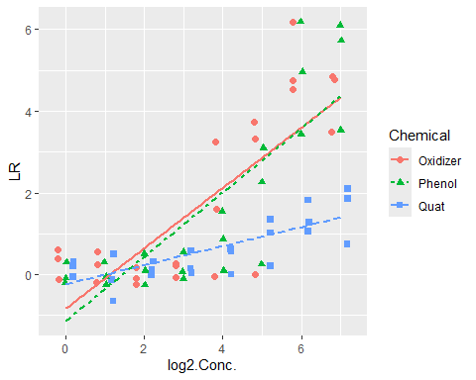

With Smoother Fit
ggplot(d,aes(y=LR,x=log2.Conc.,color=Chemical,shape=Chemical, linetype=Chemical))+geom_point(position = position_jitterdodge(jitter.width = 0.15, dodge.width = 0.6),size=2)+geom_smooth(method="loess",se=FALSE)
## `geom_smooth()` using formula = 'y ~ x'
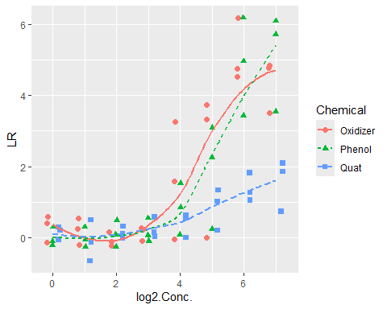

How to Model A Single Chemical Over Multiple Experiments
Check for Responsiveness to Concentration Increase (a quantitative covariate).

Plot the LRs by Concentration with Linear Fit
dt$Day = as.factor(dt$Day)
ggplot(dt,aes(y=LR,x=log2.Conc.,color=Day,shape=Day, linetype=Day))+geom_point(position = position_jitterdodge(jitter.width = 0.15, dodge.width = 0.6),size=4)+geom_smooth(method="lm",se=FALSE)
## `geom_smooth()` using formula = 'y ~ x'
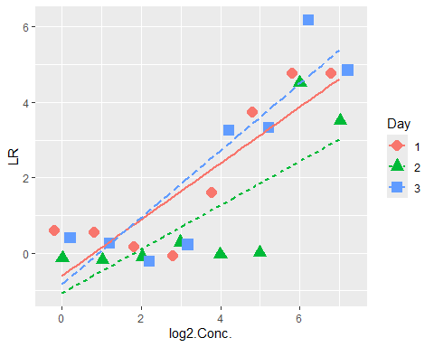

Plot the LRs by Concentration with Smoother Fit
dt = d[d$Chemical=="Oxidizer",]
dt$Day = as.factor(dt$Day)
ggplot(dt,aes(y=LR,x=log2.Conc.,color=Day,shape=Day, linetype=Day))+geom_point(position = position_jitterdodge(jitter.width = 0.15, dodge.width = 0.6),size=4)+geom_smooth(method="loess",se=FALSE)
## `geom_smooth()` using formula = 'y ~ x'
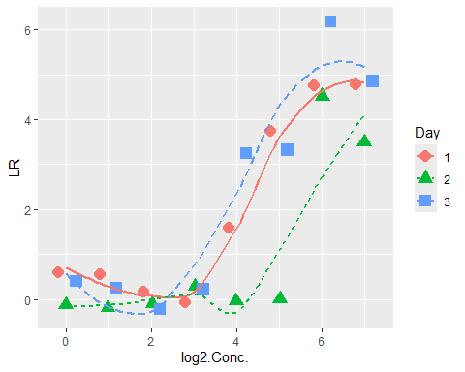

LMM Estimate Slope Pooled Overall Experiments

Fit the LMM
mean(dt$log2.Conc.)
## [1] 3.5
m = lmer(LR ~ I(log2.Conc.-mean(log2.Conc.)) + (1|Day),data=dt)
anova(m)
## Type III Analysis of Variance Table with Satterthwaite's method
## Sum Sq Mean Sq NumDF DenDF F value Pr(>F)
## I(log2.Conc. - mean(log2.Conc.)) 68.672 68.672 1 20 47.81 1.026e-06
##
## I(log2.Conc. - mean(log2.Conc.)) ***
## ---
## Signif. codes: 0 '***' 0.001 '**' 0.01 '*' 0.05 '.' 0.1 ' ' 1
summary(m)
## Linear mixed model fit by REML. t-tests use Satterthwaite's method [
## lmerModLmerTest]
## Formula: LR ~ I(log2.Conc. - mean(log2.Conc.)) + (1 | Day)
## Data: dt
##
## REML criterion at convergence: 80.3
##
## Scaled residuals:
## Min 1Q Median 3Q Max
## -1.9889 -0.5441 0.1322 0.6889 1.8802
##
## Random effects:
## Groups Name Variance Std.Dev.
## Day (Intercept) 0.2917 0.5401
## Residual 1.4363 1.1985
## Number of obs: 24, groups: Day, 3
##
## Fixed effects:
## Estimate Std. Error df t value Pr(>|t|)
## (Intercept) 1.7575 0.3963 2.0000 4.434 0.0473
## I(log2.Conc. - mean(log2.Conc.)) 0.7383 0.1068 20.0000 6.915 1.03e-06
##
## (Intercept) *
## I(log2.Conc. - mean(log2.Conc.)) ***
## ---
## Signif. codes: 0 '***' 0.001 '**' 0.01 '*' 0.05 '.' 0.1 ' ' 1
##
## Correlation of Fixed Effects:
## (Intr)
## I(2.C.-m(2. 0.000
confint(m)
## Computing profile confidence intervals ...
## 2.5 % 97.5 %
## .sig01 0.0000000 1.6030899
## .sigma 0.8885907 1.6364299
## (Intercept) 0.8539734 2.6610259
## I(log2.Conc. - mean(log2.Conc.)) 0.5243287 0.9521792

Plot LMM Predictions with Data
plot(dt$log2.Conc,dt$LR,lwd=2, xlab="Concentration",ylab="LR")
p = predict(m,re.form=~0)
lines(unique(dt$log2.Conc),unique(p),col="red",lwd=2)
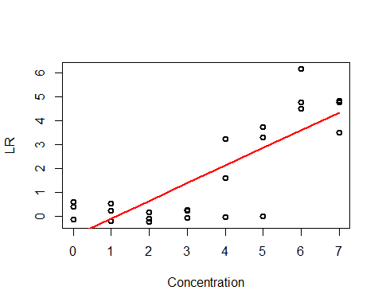
plot(allEffects(m))
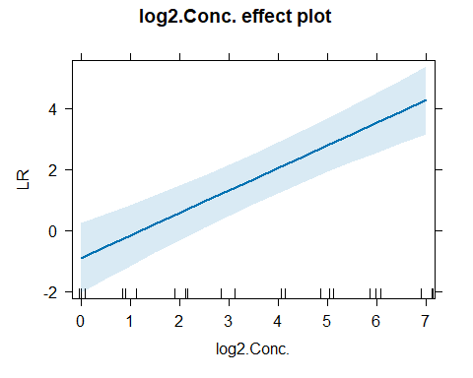

Check Model Assumptions
Check constant variance and normality of LRs
diagRES(m,res="p",num.panes=4,tests=FALSE)
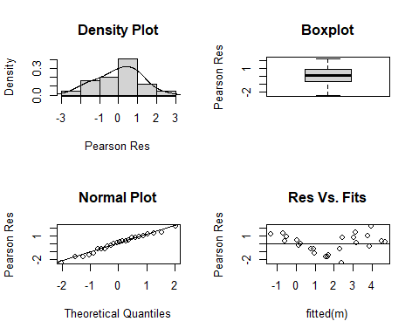
## 1 2 3 4 5 6
## 0.27076078 0.99901475 0.71726871 -0.69447732 -1.62622335 -0.63796938
## 7 8 25 26 27 28
## 0.48028459 1.26853855 -0.36010013 1.39815384 -2.38359219 -1.68533822
## 29 30 31 32 49 50
## -0.62708425 -0.26883028 0.37942368 1.17767765 0.18517268 2.25342665
## 51 52 53 54 55 56
## 0.13168062 0.79993459 -1.49181145 -1.20355748 0.01469649 0.90295046
# Check normality of experiment mean LDs
re=ranef(m)$Day
qqnorm(re[,1])
qqline(re[,1])
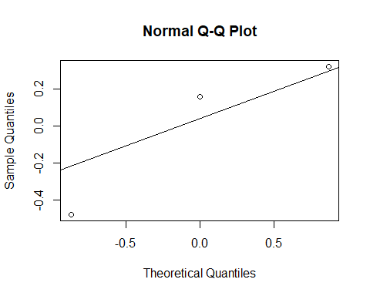

GAM Smoother Regression
Compare the Chemicals (a categorical factor)

Fit the GAM
g = gamm(LR ~ ti(log2.Conc.),random=list(Day=~1),data=dt)
summary(g$gam)
##
## Family: gaussian
## Link function: identity
##
## Formula:
## LR ~ ti(log2.Conc.)
##
## Parametric coefficients:
## Estimate Std. Error t value Pr(>|t|)
## (Intercept) 1.7575 0.3306 5.316 3.28e-05 ***
## ---
## Signif. codes: 0 '***' 0.001 '**' 0.01 '*' 0.05 '.' 0.1 ' ' 1
##
## Approximate significance of smooth terms:
## edf Ref.df F p-value
## ti(log2.Conc.) 2.893 2.893 32.82 <2e-16 ***
## ---
## Signif. codes: 0 '***' 0.001 '**' 0.01 '*' 0.05 '.' 0.1 ' ' 1
##
## R-sq.(adj) = 0.747
## Scale est. = 0.82049 n = 24
confint(g$gam)
## 2.5 % 97.5 %
## (Intercept) 1.109585 2.4054147
## ti(log2.Conc.).1 -1.874694 -0.4364134
## ti(log2.Conc.).2 -1.077548 0.3650214
## ti(log2.Conc.).3 1.293111 2.7802382
## ti(log2.Conc.).4 2.601709 4.4512044

Plot GAM predictions with data
plot(dt$log2.Conc,dt$LR,lwd=2, xlab="Concentration",ylab="LR")
pg = predict(g$gam,re.form=~0)
lines(unique(dt$log2.Conc),unique(pg),col="red",lty=1,lwd=2)
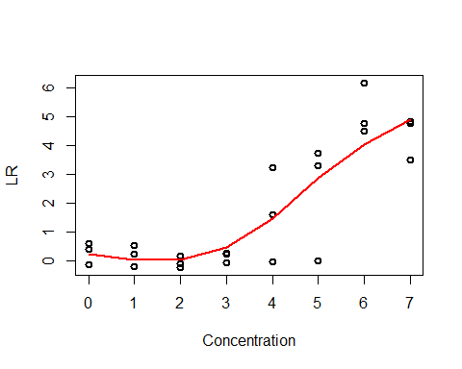

Plot comparison of GAM and LMM fits
plot(dt$log2.Conc,dt$LR,lwd=2, xlab="Concentration",ylab="LR")
pg = predict(g$gam,re.form=~0)
lines(unique(dt$log2.Conc),unique(p),col="red",lwd=2)
lines(unique(dt$log2.Conc),unique(pg),col="green",lty=2,lwd=2)
legend("topleft",c("LMM","GAM"),col=c("red","green"),lty=1:2)
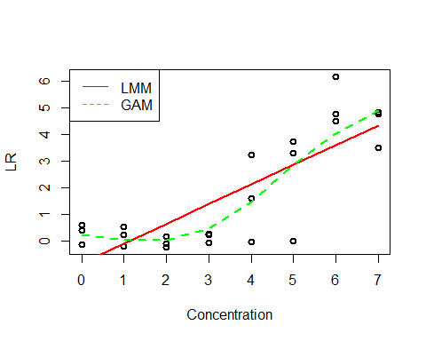

Check Model Assumptions
Check constant variance and normality of LRs
diagRES(g$lme,res="p",num.panes=4,tests=FALSE)
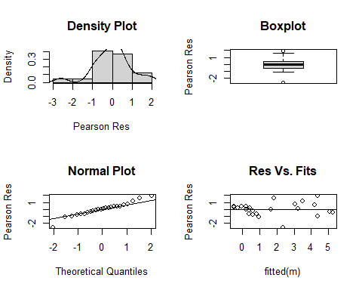
## 1/1 1/1 1/1 1/1 1/1 1/1
## -0.33099080 0.62318539 0.76600042 -0.07042640 -0.78168739 -0.04575157
## 1/1 1/1 1/2 1/2 1/2 1/2
## 0.37412964 0.20072974 -0.96528698 1.12599543 -2.59514271 -1.10215776
## 1/2 1/2 1/2 1/2 1/3 1/3
## 0.38351463 0.42393887 0.32494638 0.16258634 -0.44158483 1.99193343
## 1/3 1/3 1/3 1/3 1/3 1/3
## 0.10341309 1.56327844 -0.64940436 -0.68625917 -0.15597930 -0.21898054
## attr(,"label")
## [1] "Standardized residuals"
gam.check(g$gam)
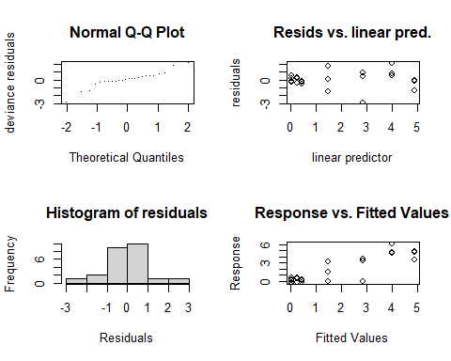
##
## 'gamm' based fit - care required with interpretation.
## Checks based on working residuals may be misleading.
## Basis dimension (k) checking results. Low p-value (k-index<1) may
## indicate that k is too low, especially if edf is close to k'.
##
## k' edf k-index p-value
## ti(log2.Conc.) 4.00 2.89 1.19 0.8
plot.gam(g$gam)
