Reproducibility and Repeatability of the STM
COST: Biofilm Regulatory Toolbox
8 Sept 2026
Showing Reproducibility and Repeatability of the STM to 6 different treatments against Pseudomonas biofilms in the CDC reactor. Data generated by 6 laboratories and reported by Goeres et al 2019:
Goeres, Walker, Buckingham-Meyer, Lorenz, Summers, Fritz, Goveia, Dickerman, Schultz, and Parker. Development, standardization, and validation of a biofilm efficacy test: the single tube method. Journal of Microbiological Methods. 165, 2019

Housekeeping
library(lme4) # lmer()
## Warning: package 'lme4' was built under R version 4.4.2
## Loading required package: Matrix
source("diagRES.r")
library(lmerTest)
## Warning: package 'lmerTest' was built under R version 4.4.2
##
## Attaching package: 'lmerTest'
## The following object is masked from 'package:lme4':
##
## lmer
## The following object is masked from 'package:stats':
##
## step
library(effects)
## Warning: package 'effects' was built under R version 4.4.3
## Loading required package: carData
## Warning: package 'carData' was built under R version 4.4.3
## lattice theme set by effectsTheme()
## See ?effectsTheme for details.
library(ggplot2)
## Warning: package 'ggplot2' was built under R version 4.4.3

Get Data
d = read.csv("Parker_10-11_STM_LRs_6Labs.csv",stringsAsFactors = TRUE)
d$Treatment = factor(d$Treatment,levels=c("Chlorine_LOW","Chlorine_HIGH", "Phenol_LOW", "Phenol_HIGH", "Quat-alcohol_LOW", "Quat-alcohol_HIGH"))
summary(d)
## Lab Date Exp Tech Conc
## Min. :1.000 10/25/2012:12 Min. :1.0 Min. :1.000 HIGH:54
## 1st Qu.:2.000 10/18/2012: 9 1st Qu.:2.0 1st Qu.:1.000 LOW :54
## Median :4.000 10/4/2012 : 9 Median :3.5 Median :1.000
## Mean :4.167 9/20/2012 : 9 Mean :3.5 Mean :1.528
## 3rd Qu.:6.000 10/11/2012: 6 3rd Qu.:5.0 3rd Qu.:2.000
## Max. :8.000 11/1/2012 : 6 Max. :6.0 Max. :5.000
## (Other) :57
## MeanLD LR SonFreq SonMan De.gas
## Min. :1.338 Min. :0.4879 Min. :40.00 Branson:54 Min. :0.0
## 1st Qu.:4.396 1st Qu.:2.3108 1st Qu.:40.00 Elma :18 1st Qu.:0.0
## Median :5.509 Median :3.0506 Median :40.00 FS :36 Median :0.5
## Mean :5.116 Mean :3.4332 Mean :41.17 Mean :0.5
## 3rd Qu.:6.111 3rd Qu.:4.2715 3rd Qu.:42.00 3rd Qu.:1.0
## Max. :7.890 Max. :7.2631 Max. :45.00 Max. :1.0
##
## VialPlacement LabTemp Chemical Treatment
## F:18 Min. :18.00 Chlorine :36 Chlorine_LOW :18
## S:90 1st Qu.:19.00 Phenol :36 Chlorine_HIGH :18
## Median :21.05 Quat-alcohol:36 Phenol_LOW :18
## Mean :20.89 Phenol_HIGH :18
## 3rd Qu.:22.50 Quat-alcohol_LOW :18
## Max. :25.60 Quat-alcohol_HIGH:18
##

Plot the data
ggplot(d, aes(x = Chemical, y = LR, color = Chemical, group = Conc, shape = Conc)) +
geom_point(
position = position_jitterdodge(jitter.width = 0.15, dodge.width = 0.6),
size = 3,
alpha = 1) +
stat_summary(
fun = "mean",
geom = "crossbar",
position = position_dodge(width = 0.6),
size = 0.5)
## Warning: Using `size` aesthetic for lines was deprecated in ggplot2 3.4.0.
## ℹ Please use `linewidth` instead.
## This warning is displayed once every 8 hours.
## Call `lifecycle::last_lifecycle_warnings()` to see where this warning was
## generated.
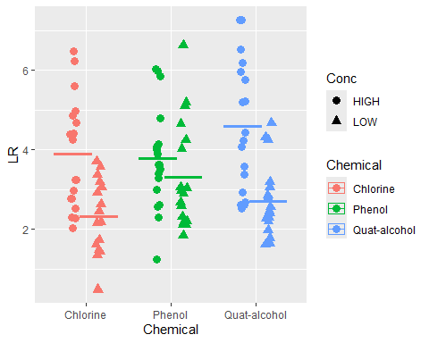

Get Reproducibility for each Chemical and Concentration Combination

Fit the model
m = lmer(LR ~ (1|Lab),data=d[d$Chemical=="Chlorine"&d$Conc=="HIGH",])
summary(m)
## Linear mixed model fit by REML. t-tests use Satterthwaite's method [
## lmerModLmerTest]
## Formula: LR ~ (1 | Lab)
## Data: d[d$Chemical == "Chlorine" & d$Conc == "HIGH", ]
##
## REML criterion at convergence: 62.1
##
## Scaled residuals:
## Min 1Q Median 3Q Max
## -1.2669 -0.5962 -0.1308 0.7735 1.6622
##
## Random effects:
## Groups Name Variance Std.Dev.
## Lab (Intercept) 0.2671 0.5168
## Residual 1.7055 1.3059
## Number of obs: 18, groups: Lab, 6
##
## Fixed effects:
## Estimate Std. Error df t value Pr(>|t|)
## (Intercept) 3.8906 0.3732 5.0000 10.43 0.00014 ***
## ---
## Signif. codes: 0 '***' 0.001 '**' 0.01 '*' 0.05 '.' 0.1 ' ' 1
confint(m) # for 2-sided 95% CI
## Computing profile confidence intervals ...
## 2.5 % 97.5 %
## .sig01 0.0000000 1.500425
## .sigma 0.9174146 1.944510
## (Intercept) 3.1002697 4.680862
confint(m, level=0.9) # for upper 1-sided 95% CI
## Computing profile confidence intervals ...
## 5 % 95 %
## .sig01 0.0000000 1.266197
## .sigma 0.9655156 1.821282
## (Intercept) 3.2606938 4.520438

Reproducibility and Repeatability
VarCorr(m)
## Groups Name Std.Dev.
## Lab (Intercept) 0.51682
## Residual 1.30595
vc = as.data.frame(VarCorr(m))$vcov
# Proportion of variance components
vc/sum(vc)
## [1] 0.1354044 0.8645956
# Reproducibility of the LRs
sqrt(sum(vc))
## [1] 1.404491
# Repeatability of the LRs (estimated by pooling over all labs)
sqrt(vc[2])
## [1] 1.305947

Check model assumptions
Check constant variance and normality of coupon LDs in each experiment
diagRES(m,res="p",num.panes=4,tests=FALSE)
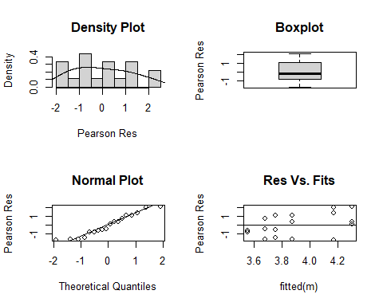
# Check normality of lab mean LDs
re=ranef(m)$Lab
qqnorm(re[,1])
qqline(re[,1])
