Ruggedness of STM
COST: Biofilm Regulatory Toolbox
8 Sept 2026
Showing Ruggedness of the STM to different treatments against Pseudomonas biofilms in the CDC reactor. Data generated by CBE and reported by Goeres et al 2019:
Goeres, Walker, Buckingham-Meyer, Lorenz, Summers, Fritz, Goveia, Dickerman, Schultz, and Parker. Development, standardization, and validation of a biofilm efficacy test: the single tube method. Journal of Microbiological Methods. 165, 2019

Housekeeping
library(lme4) # lmer()
## Warning: package 'lme4' was built under R version 4.4.2
## Loading required package: Matrix
source("diagRES.r")
library(lmerTest)
## Warning: package 'lmerTest' was built under R version 4.4.2
##
## Attaching package: 'lmerTest'
## The following object is masked from 'package:lme4':
##
## lmer
## The following object is masked from 'package:stats':
##
## step
library(effects)
## Warning: package 'effects' was built under R version 4.4.3
## Loading required package: carData
## Warning: package 'carData' was built under R version 4.4.3
## lattice theme set by effectsTheme()
## See ?effectsTheme for details.
library(ggplot2)
## Warning: package 'ggplot2' was built under R version 4.4.3

Get Data
d = read.csv("STM_Ruggedness.csv",stringsAsFactors = TRUE)
d$Power_Time=factor(d$Power_Time,levels=c("20_25", "20_35", "80_30", "200_25", "200_35")) # Get the order correct for ggplot()
summary(d)
## Exp Power Time Degas LD
## Min. :1.000 Min. : 20.0 Min. :25 N:15 Min. :8.065
## 1st Qu.:1.000 1st Qu.: 20.0 1st Qu.:25 Y:18 1st Qu.:8.319
## Median :2.000 Median : 80.0 Median :30 Median :8.433
## Mean :1.545 Mean :101.8 Mean :30 Mean :8.375
## 3rd Qu.:2.000 3rd Qu.:200.0 3rd Qu.:35 3rd Qu.:8.478
## Max. :2.000 Max. :200.0 Max. :35 Max. :8.604
## Power...80 Time...30 Power_Time Time_Degas Power_Degas
## Min. :-60.00 Min. :-5 20_25 :6 25_N:6 20_N :6
## 1st Qu.:-60.00 1st Qu.:-5 20_35 :6 25_Y:6 20_Y :6
## Median : 0.00 Median : 0 80_30 :9 30_N:3 200_N:6
## Mean : 21.82 Mean : 0 200_25:6 30_Y:6 200_Y:6
## 3rd Qu.:120.00 3rd Qu.: 5 200_35:6 35_N:6 80_N :3
## Max. :120.00 Max. : 5 35_Y:6 80_Y :6

Plot the LDs vs Covariates
View the data a few different ways.
ggplot(d, aes(x = Degas, y = LD, group = Power_Time, color = as.factor(Power), shape = as.factor(Time))) +
geom_point(position = position_jitterdodge(jitter.width = 0.15, dodge.width = 0.6),
size = 3)
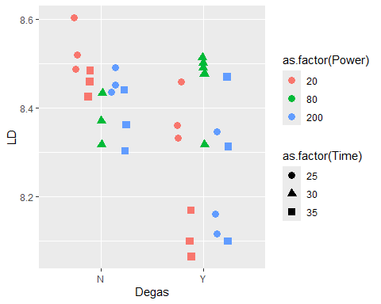
ggplot(d, aes(x = as.factor(Power), y = LD, group = Time_Degas, color = as.factor(Time), shape = Degas)) +
geom_point(position = position_jitterdodge(jitter.width = 0.15, dodge.width = 0.6),
size = 3)
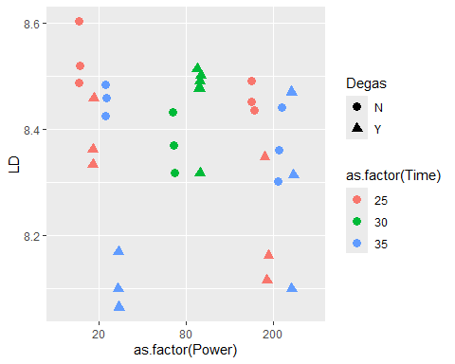
ggplot(d, aes(x = as.factor(Time), y = LD, group = Power_Degas, color = as.factor(Power), shape = Degas)) +
geom_point(position = position_jitterdodge(jitter.width = 0.15, dodge.width = 0.6),
size = 3)
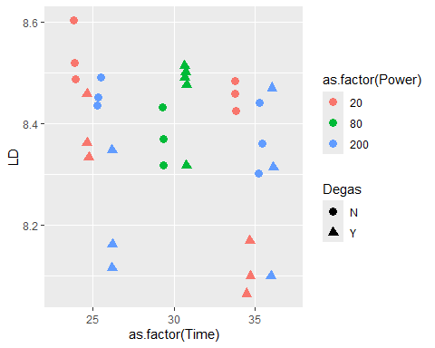

Assess Ruggedness
Centering at SOP values is crucial for interpretation of the interactions!

Fit Mixed Effects Multiple Regression w All interactions
m = lmer(LD ~ Degas*I(Power-80)*I(Time - 30) + (1|Exp),data=d)
summary(m)
## Linear mixed model fit by REML. t-tests use Satterthwaite's method [
## lmerModLmerTest]
## Formula: LD ~ Degas * I(Power - 80) * I(Time - 30) + (1 | Exp)
## Data: d
##
## REML criterion at convergence: 30.7
##
## Scaled residuals:
## Min 1Q Median 3Q Max
## -2.07963 -0.63242 0.04162 0.27352 2.03709
##
## Random effects:
## Groups Name Variance Std.Dev.
## Exp (Intercept) 0.01576 0.1255
## Residual 0.01147 0.1071
## Number of obs: 33, groups: Exp, 2
##
## Fixed effects:
## Estimate Std. Error df t value
## (Intercept) 8.366e+00 9.861e-02 1.119e+00 84.839
## DegasY 1.319e-02 6.519e-02 2.317e+01 0.202
## I(Power - 80) -3.900e-04 3.397e-04 2.400e+01 -1.148
## I(Time - 30) -8.460e-03 6.517e-03 2.400e+01 -1.298
## DegasY:I(Power - 80) 2.532e-04 4.802e-04 2.404e+01 0.527
## DegasY:I(Time - 30) -6.903e-03 9.216e-03 2.400e+01 -0.749
## I(Power - 80):I(Time - 30) -5.823e-06 6.869e-05 2.400e+01 -0.085
## DegasY:I(Power - 80):I(Time - 30) 2.054e-04 9.715e-05 2.400e+01 2.114
## Pr(>|t|)
## (Intercept) 0.00455 **
## DegasY 0.84145
## I(Power - 80) 0.26228
## I(Time - 30) 0.20655
## DegasY:I(Power - 80) 0.60281
## DegasY:I(Time - 30) 0.46110
## I(Power - 80):I(Time - 30) 0.93315
## DegasY:I(Power - 80):I(Time - 30) 0.04510 *
## ---
## Signif. codes: 0 '***' 0.001 '**' 0.01 '*' 0.05 '.' 0.1 ' ' 1
##
## Correlation of Fixed Effects:
## (Intr) DegasY I(P-80 I(T-30 DY:I-8 DY:I-3 I(-8-3
## DegasY -0.388
## I(Power-80) -0.083 0.125
## I(Time-30) 0.000 0.000 0.000
## DgY:I(P-80) 0.033 -0.098 -0.707 0.000
## DgY:I(T-30) 0.000 0.000 0.000 -0.707 0.000
## I(P-80):I-3 0.000 0.000 0.000 -0.316 0.000 0.224
## DY:I(P-80-3 0.000 0.000 0.000 0.224 0.000 -0.316 -0.707
confint(m)
## Computing profile confidence intervals ...
## 2.5 % 97.5 %
## .sig01 0.000000e+00 0.3635669267
## .sigma 7.515771e-02 0.1261463126
## (Intercept) 8.143729e+00 8.5705759611
## DegasY -1.800804e-01 0.1237850499
## I(Power - 80) -9.991995e-04 0.0002192168
## I(Time - 30) -2.014677e-02 0.0032265037
## DegasY:I(Power - 80) -6.285859e-04 0.0010984290
## DegasY:I(Time - 30) -2.343086e-02 0.0096239471
## I(Power - 80):I(Time - 30) -1.290112e-04 0.0001173647
## DegasY:I(Power - 80):I(Time - 30) 3.115271e-05 0.0003795810

Investigate 3-way interaction
Model each Degas level separately, have to drop the RE due to Exp bc each degas was on a separate Exp:
m.DegasN = lm(LD ~ I(Power-80)*I(Time - 30),data=d[d$Degas=="N",])
summary(m.DegasN)
##
## Call:
## lm(formula = LD ~ I(Power - 80) * I(Time - 30), data = d[d$Degas ==
## "N", ])
##
## Residuals:
## Min 1Q Median 3Q Max
## -0.130235 -0.020200 0.004456 0.035724 0.091421
##
## Coefficients:
## Estimate Std. Error t value Pr(>|t|)
## (Intercept) 8.449e+00 1.778e-02 475.209 <2e-16 ***
## I(Power - 80) -3.900e-04 2.095e-04 -1.861 0.0896 .
## I(Time - 30) -8.460e-03 4.020e-03 -2.105 0.0591 .
## I(Power - 80):I(Time - 30) -5.823e-06 4.237e-05 -0.137 0.8932
## ---
## Signif. codes: 0 '***' 0.001 '**' 0.01 '*' 0.05 '.' 0.1 ' ' 1
##
## Residual standard error: 0.06605 on 11 degrees of freedom
## Multiple R-squared: 0.4391, Adjusted R-squared: 0.2861
## F-statistic: 2.87 on 3 and 11 DF, p-value: 0.08487
confint(m.DegasN)
## 2.5 % 97.5 %
## (Intercept) 8.409757e+00 8.488021e+00
## I(Power - 80) -8.511665e-04 7.118392e-05
## I(Time - 30) -1.730701e-02 3.867399e-04
## I(Power - 80):I(Time - 30) -9.907749e-05 8.743099e-05
m.DegasY = lm(LD ~ I(Power-80)*I(Time - 30),data=d[d$Degas=="Y",])
summary(m.DegasY)
##
## Call:
## lm(formula = LD ~ I(Power - 80) * I(Time - 30), data = d[d$Degas ==
## "Y", ])
##
## Residuals:
## Min 1Q Median 3Q Max
## -0.24045 -0.11196 -0.02204 0.14620 0.18854
##
## Coefficients:
## Estimate Std. Error t value Pr(>|t|)
## (Intercept) 8.326e+00 3.667e-02 227.023 <2e-16 ***
## I(Power - 80) -2.354e-04 4.735e-04 -0.497 0.6267
## I(Time - 30) -1.536e-02 9.148e-03 -1.679 0.1152
## I(Power - 80):I(Time - 30) 1.995e-04 9.643e-05 2.069 0.0575 .
## ---
## Signif. codes: 0 '***' 0.001 '**' 0.01 '*' 0.05 '.' 0.1 ' ' 1
##
## Residual standard error: 0.1503 on 14 degrees of freedom
## Multiple R-squared: 0.2892, Adjusted R-squared: 0.1369
## F-statistic: 1.899 on 3 and 14 DF, p-value: 0.1762
confint(m.DegasY)
## 2.5 % 97.5 %
## (Intercept) 8.247288e+00 8.4046061534
## I(Power - 80) -1.250903e-03 0.0007800610
## I(Time - 30) -3.498457e-02 0.0042573887
## I(Power - 80):I(Time - 30) -7.279674e-06 0.0004063669

Plot Regression Predictions
plot(allEffects(m.DegasN))
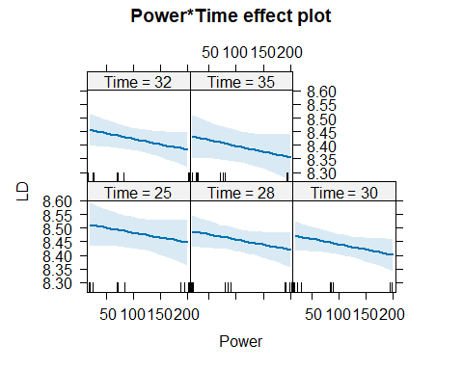
plot(allEffects(m.DegasY))
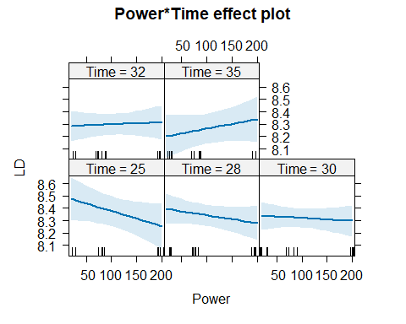

Check Model Assumptions
Check constant variance and normality of coupon LDs in each experiment
diagRES(m.DegasN,res="p",num.panes=4,tests=FALSE)
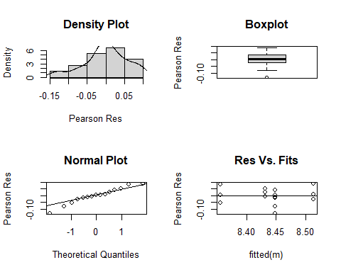
diagRES(m.DegasY,res="p",num.panes=4,tests=FALSE)
