**SUPPORTING INFORMATION for:**

**Whole cell kinetics of ureolysis by *Sporosarcina pasteurii***

Ellen G. Lauchnora,†*, Dayla Toppa,b, Al Parkera, Robin Gerlacha,b,*

aCenter for Biofilm Engineering, Montana State University, Bozeman, MT 59717

bDepartment of Chemical and Biological Engineering, Montana State University, Bozeman, MT 59717

*corresponding authors: [ellen.lauchnor@biofilm.montana.edu](mailto:ellen.lauchnor@biofilm.montana.edu) (406)994-2674, [robin_g@coe.montana.edu](mailto:robin_g@coe.montana.edu) (406)994-1840

This supporting information document contains 5 pages, one table and 3 figures.

***Table S1.*** *Individual rate data used in kinetic model parameter optimization.*

|  |  |  |  |  |
| --- | --- | --- | --- | --- |
| Experimental Day | Urea  (mmol L-1) | Ureolysis rate  (mmol L-1 hr-1) | Cell Conc.  (CFU mL-1) | CFU normalized rate  (mmol CFU-1 h-1) |
| 1 | 727 | 134 | 3.6E+7 | 3.7E-9 |
| 1 | 712 | 110 | 3.5E+7 | 3.2E-9 |
| 1 | 727 | 142 | 3.4E+7 | 4.1E-9 |
| 2 | 565 | 129 | 3.6E+7 | 3.6E-9 |
| 2 | 539 | 117 | 3.3E+7 | 3.5E-9 |
| 2 | 523 | 140 | 3.3E+7 | 4.2E-9 |
| 1 | 426 | 141 | 3.6E+7 | 4.0E-9 |
| 1 | 417 | 135 | 4.1E+7 | 3.3E-9 |
| 1 | 426 | 123 | 3.9E+7 | 3.2E-9 |
| 1 | 317 | 118 | 3.6E+7 | 3.2E-9 |
| 1 | 320 | 129 | 3.0E+7 | 4.3E-9 |
| 1 | 305 | 101 | 3.0E+7 | 3.4E-9 |
| 3 | 317 | 118 | 3.0E+7 | 3.9E-9 |
| 3 | 323 | 119 | 2.7E+7 | 4.4E-9 |
| 3 | 318 | 106 | 3.1E+7 | 3.5E-9 |
| 2 | 264 | 83 | 2.9E+7 | 2.9E-9 |
| 2 | 266 | 97 | 3.0E+7 | 3.3E-9 |
| 2 | 268 | 78 | 3.0E+7 | 2.7E-9 |
| 3 | 179 | 53 | 3.5E+7 | 1.5E-9 |
| 3 | 179 | 54 | 3.6E+7 | 1.5E-9 |
| 3 | 179 | 53 | 5.0E+7 | 1.1E-9 |
| 3 | 60 | 20 | 3.5E+7 | 5.6E-10 |
| 3 | 50 | 14 | 3.6E+7 | 3.9E-10 |
| 3 | 52 | 15 | 3.1E+7 | 4.7E-10 |
| 3 | 23 | 9.1 | 3.4E+7 | 2.7E-10 |
| 3 | 14 | 5.0 | 3.3E+7 | 1.5E-10 |
| 3 | 17 | 6.3 | 3.1E+7 | 2.0E-10 |
| 3 | 7.7 | 1.4 | 3.0E+7 | 4.8E-11 |
| 3 | 7.8 | 1.4 | 3.4E+7 | 4.0E-11 |
| 3 | 8.1 | 1.5 | 3.2E+7 | 4.6E-11 |
| 2 | 4.3 | 2.2 | 3.2E+7 | 6.7E-11 |
| 2 | 2.9 | 1.5 | 3.2E+7 | 4.6E-11 |
| 2 | 3.9 | 2.1 | 3.0E+7 | 7.2E-11 |
| 2 | 1.2 | 0.7 | 3.7E+7 | 1.9E-11 |
| 2 | 1.1 | 0.5 | 3.6E+7 | 1.5E-11 |
| 2 | 1.1 | 0.5 | 3.4E+7 | 1.3E-11 |

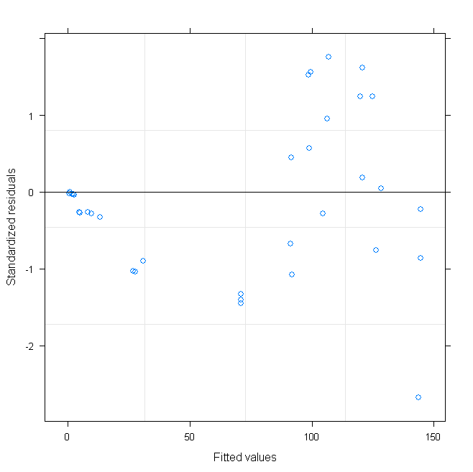

***Figure S1.*** *Residuals for non-linear mixed effects model with random effect for Km.*

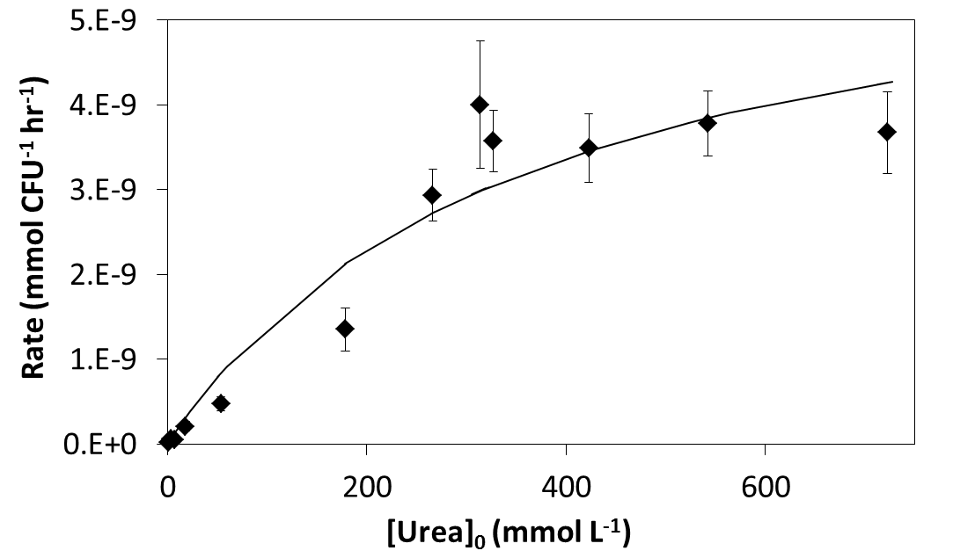

**Vmax = 6.4 e-9 mmol CFU-1 h-1**

**Km = 355 mmol L-1**

**R-Squared = 0.947**

***Figure S2.*** *Michaelis-Menten model fit to ureolysis rates normalized to CFU, which was calculated from a relationship with OD600 (Parks 2009). Range of OD600 values for these experiments was 0.026 +/- 0.004. Error bars are standard deviations of triplicate batch reactors and are smaller than the markers if not visible.*

Sensitivity analyses were performed for the optimized values of Vmax and Km for both the non-linear least squares (nls) and non-linear mixed effects (*nlme*) models. Figure S3 shows a contour plot of the log of the non-linear least squares cost function. The optimal Vmax = 216 and Km = 359 found by the nls procedure is shown with the red asterisk (*); the optimal Vmax = 200 and Km = 305 found by *nlme* is shown with the red circle (o). In both cases, the direction of maximum sensitivity of the model fit to the data was found by performing an eigen-decomposition of the covariance matrix of Vmax and Km. This plot shows that from either optimum, the direction of least sensitivity of the model’s fit to the data is in the direction Vmax + 4xKm, while the direction of maximum sensitivity is in the direction 4xVmax - Km. This shows that the model fit to the data is most affected by changes in Vmax.



***Figure S3.*** *Contour plot of the log of the non-linear least squares cost function.*